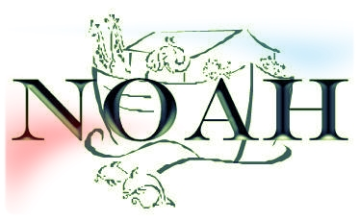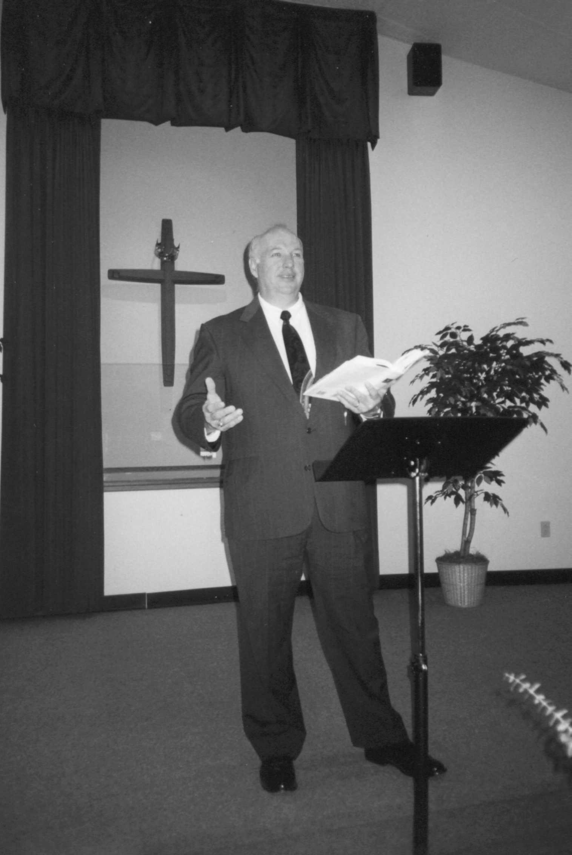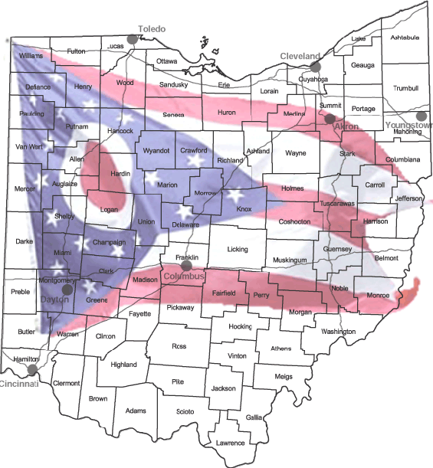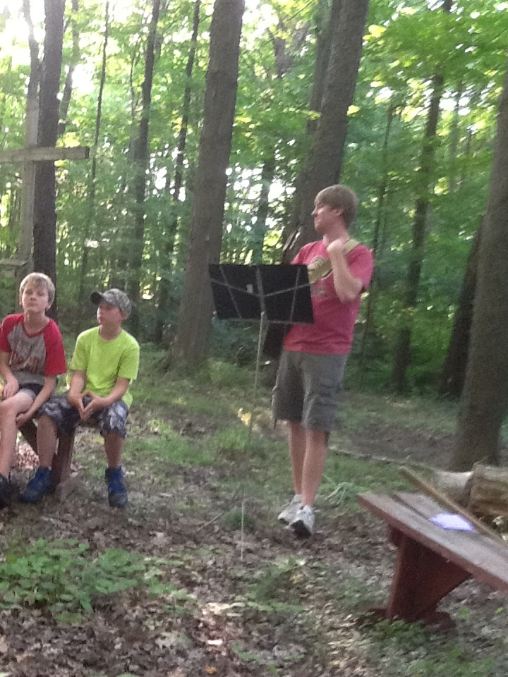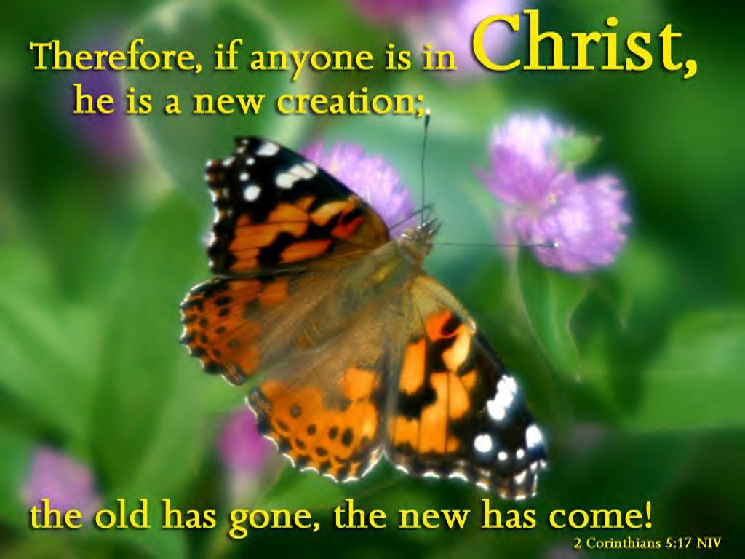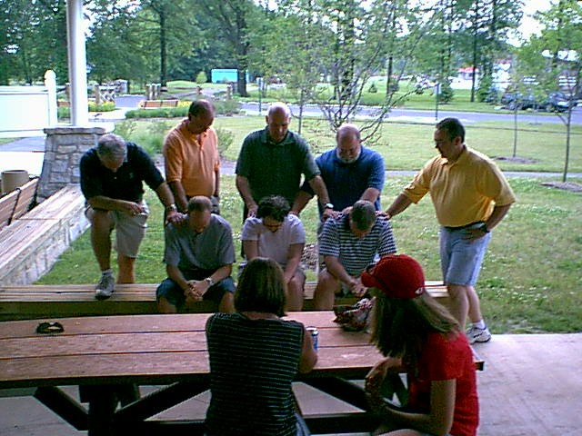

We will be going to the Center for Church Leadership

Summit, 3/9/19, in Cincinnati.

The NOAH Annual Meeting will be online this year. Please be watching inbox!

The current NCSC Call is designated for the Valley Christian Church.

Our vision is to make disciple who plant churches! We would like to make church planting a normal, everyday, healthy, intentional part of every disciples life! That vision also carries over into our local congregations as disciples serve their communities.

With that being said, NOAH absolutely needs help to accomplish this God given vision. Jesus instructed us to pray for ***workers, because the fields are already ripe and ready to be harvested!*** ( see what I did right there? You thought that I was going to ask for money right?? ☺) Continued on Next Page

#### Save the Date!

We are excited to share the news with you that after years of looking, praying, and searching God opened the door for Valley Christian Church to be in their own facility! Their worship attendance more than doubled when they held their very first public worship service in their new building. Since they moved into their building, they continue to have first time guests in worship with them nearly every Sunday! We say, “Yea God!!!!”

NOAH News is Good News!

NEWS

Fall 2018

##### NCSC Call

##### CCL

##### Annual Meeting

# Valley Moves into their

# New Facilities!

### HELP WANTED!

* Each church that we plant works with a leadership team composed of NOAH Directors and members from our partner churches. **We always are looking for godly men who are willing to serves as a part of the management team for a new church.**
* As a church planting ministry, NOAH has a leadership team as well. We call this team our Board of Directors. These men of God are vital to the continuation of our mission! These men serve on a three-year rotating basis and give guidance, council, and assistance to our area churches as well as our new churches. We always need more men to serve on our leadership team. If you, or someone that you know may be interested in this type of continuing ministry, please let us know! We would love to have a conversation with them!

***Can we count on you???***

There are actually tons of ways that you can be an active partner with NOAH and do hands-on church planting. Let me know if you are interested in serving in any of the following ways:

* Help a new church with an outreach event, such as helping distribute brochures, manage a booth for something like a back-to-school rally, helping with sporting events, or something like that.
* Serving on the renovation team to help transform a facility into a contemporary worship and discipleship center.
* Serve as one of our prayer partners and help to “break up the hard spiritual ground” of a community prior to outreach events or other community involvement efforts.

# NOAH Needs Help, Continued

## **TEAM NOAH Needs You!**

***Team NOAH is recruiting people who are committed to take their next steps in following Jesus in the area of church planting. If you would like to serve as a part of the launch team for a new church, please let us know. We would love to have a conversation with you!***

[***Churchplanter101@sbcglobal.net***](mailto:Churchplanter101@sbcglobal.net)

***330-877-1448***

***TeamNOAH.cc***

The Rotating Loan Fund is a fund that was established to help New Churches at one of two crucial times. It was designed to help a congregation secure property for the first time, or to help a congregation complete some of the capital expenses after moving into a new facility.

This ministry opportunity has been a tremendous blessing to churches who usually do not have an established line of credit, or use it to secure a larger loan.

The NOAH New Church Sponsor Club is made up of individuals who desire to help support a new church financially. NOAH sends out a call three times per year for a designated, pass-through gift for a new church plant, or for the Rotating Loan Fund. This call generally generates, on average, a gift of $3,000.00 to $5,000.00 per call, and is given in entirety to people who need it most.

NOAH committed to help plant three churches in three years. Those churches are all doing well! Valley (Youngstown) took their next steps of growth in developing disciples and securing their first facility.

Compass continues to be a leading voice in Kenmore (Akron) as they reach out through the Open Tone Music academy, as well as leading in the community business association.

Velocity (Cleveland) has had steady, phenomenal growth since their inception! They outgrew their rented facilities in Lyndhurst, and planted a satellite congregation in Mentor. Now they are outgrowing both locations and praying for God’s continued leading.

All three of these churches are being planted in urban areas. God is alive and well and reaching high-density population areas with Good News from the loving God who pursues us with His offer of salvation through His son Jesus Christ!

## Rotating Loan Fund

# The Year in Review

## New Church Sponsor Club

## Effective Church Plants Supported



PO Box 8251  
Canton, Ohio 44711

What does 2019 and beyond look like?

We would like to help Valley Christian Church plant daughter church number one and two.

We would like to help Velocity Christian Church take their next steps as they follow Jesus in multiplication.

We would like to help the Northside Christian Church (Wadsworth) plant a satellite church in Medina.

We would like to help Momentum Christian Church (Garfield Heights, Cleveland) secure their first permanent facility, and plant another church.

We have made a commitment to continue to help churches that need to make a **C**hange, or are in **C**onflict, or are working through a **C**onfusing situation.

Especially prepared for the Team NOAH.

Those who support the vision, mission and service of the Northeastern Ohio Association of Helpers.

“What’s Up?”

Fall 2016

NOAH NEWS is Good News!